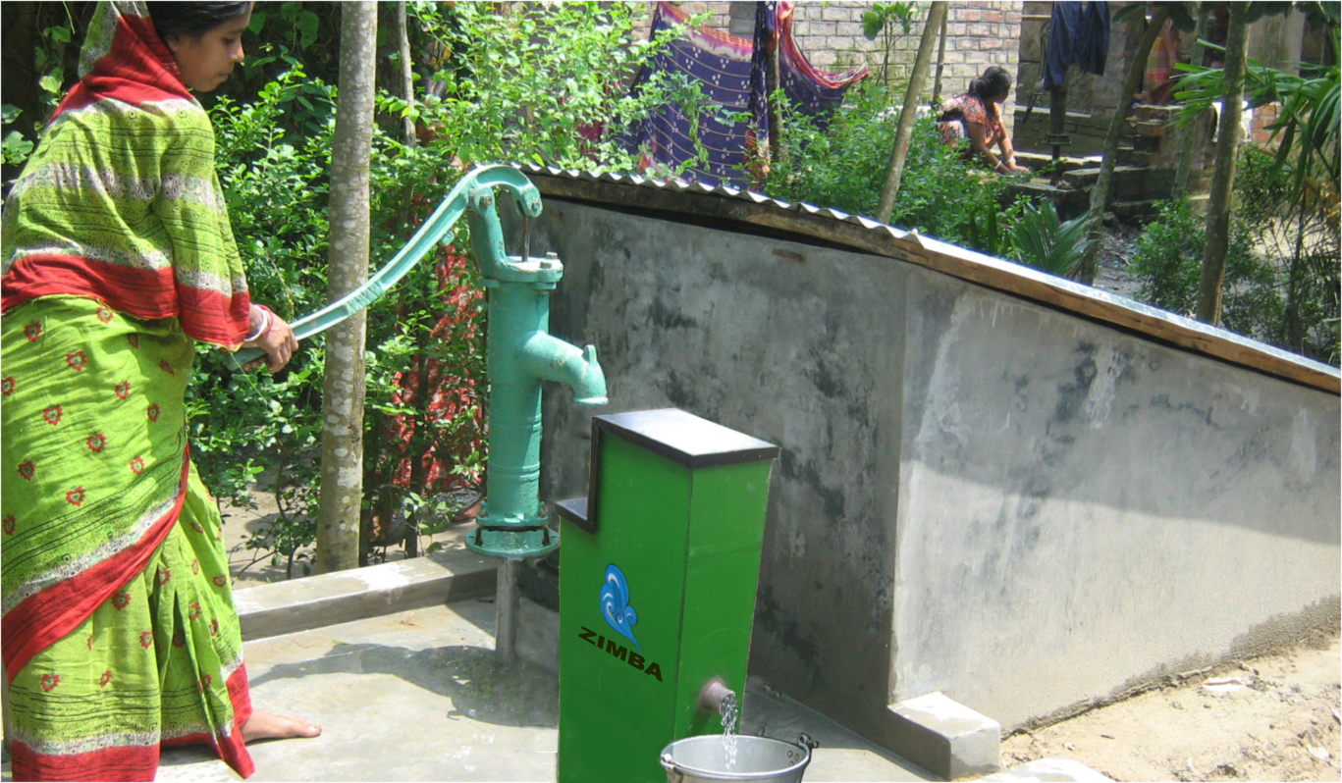
MICROGRANTS
Application Form

Overview
Our microgrants are intended people that have attended an International Development Innovaiton Summit (IDDS) with funding for specific tasks that progress the development of their technology, product or venture. IDIN awards microgrants, typically from $500 - $2,000, twice a year.

Microgrants are designed to fund ideas that are innovative, practical, and sustainable. We support innovators that engage in co-creation and projects that will make a difference in the lives of those living in poverty.

We support projects in the ideation phase, development phase, and piloting phase. Microgrants, for example, can be used to build a next generation prototype, conduct a pilot trial, perform market research, test a manufacturing process, hire legal services, or perform other critical tasks that transform your prototype into a product or your product into a venture.

Each application should enable a critical step to move a project forward; once that step is completed, it is possible to apply again, for a maximum of three times for the same project. Microgrants may not be used for international travel or personal stipends.

Email us at idin.microgrants@mit.edu with any questions.

Eligibility
In order to be eligible for a microgrant, you need to fulfill the following criteria:
- You have participated in IDDS in the past.
- Your project focus is on technology innovation, product design, and venture creation.
- Your project aims for social impact in the developing world.
- You have established partnerships with individuals or key organizations in the community where you will be working.
- You can utilize the funds within six months of receipt.

The following types of projects are not eligible for consideration under IDIN microgrant funding:
- Research projects (where research is the primary focus)
- Workshops or training activities
- Traditional development projects

Application Guidelines
- Deadline for applications is Monday October 10th, 2016
- Please submit your completed application to idin.microgrants@mit.edu

Evaluation Criteria
IDIN gives priority to well-crafted proposals for innovative, scalable projects that address basic social and environmental needs. The completed application for Part 1 and Part 2 below should be between 3-5 pages long, not including budget and supplementary materials.

When selecting recipients, IDIN seeks to fund across different sectors and locations. We evaluate the following:
- The applicant (20%): What is his/her motivation and commitment to the project? Does she/he have the skills and experience to implement what he/she proposes?
- The project (20%): Is the project innovative? Is it addressing a real need? Will the proposed idea have social impact?
- The context (20%): Does the applicant have strong partnerships and support? Is he/she connected to the target community?
- The sustainability model (20%) Is there a potential for scale and sustainability? Is there a market or a clear dissemination model?
- The workplan and budget (20%): Is the timeline realistic and feasible? Is there a clear implementation strategy?

You will be notified if your idea has been selected for an IDIN microgrant by (the latest) November 30th 2014.

We look forward to supporting your idea!

APPLICATION FORM

Please review all of the guidelines and eligibility criteria before completing the application. The completed application for Part 1 and Part 2 should be between 3-5 pages long, not including budget and supplementary materials.

Part 1. BACKGROUND INFORMATION
Your responses for this section should be less than 1 page long.

Your name:

Which IDDS(s) did you attend?

Your email:

Your telephone number:

Your address:

Location of your project:
*If the project activities are not in the vicinity of your hometown, please provide us information about how you plan to solve distance challenges.

Summarize your idea for us in 1-2 sentences.
Describe what you will do, where you will do it, and what the result will be.

____________________________________________________________________________________

Part 2. DETAILS ABOUT YOUR PROJECT
Your responses for this section should be 2-4 pages long.

*If this is your second time applying for a microgrant, please answer each question below clarifying what you have achieved so far, and what you hope to achieve with an additional grant.

1) What is the problem you are trying to solve?
Explain the causes of this problem and why the problem still exists. Please provide some evidence and background research.

2) Briefly describe who (or what) you aim to help.
Who is your target user/audience?

3) What is your proposed solution?
Include a detailed description of your idea or design. Include information about the concept and how it will work. What work has already been done? [If you have drawings, pictures or videos include them as supplementary materials]

4) Why is your product or service innovative?
Describe, if applicable, what other competing solutions exist out there? Why is your idea better? If you have already done some work on your project/prototype please describe it in detail (and attach a picture, if possible).

5) Please describe what you hope to achieve with the microgrant funding.
What will be the result or the outcome after working on this project for 6-months?

6) Describe the main activities you will carry out in a six month time period (the microgrant duration):

EXAMPLE timeline, but feel free to use your own format.

Activity | Month 1 | Month 2 | Month 3 | Month 4 | Month 5 | Month 6
Description of Activity 1
Activity 2
Activity …
Activity …

7) What are some of the challenges that you think you will face during this time? How will you address these risks?

8) What is your long-term goal for the project? How will it become sustainable or commercially viable?

9) Explain to us how this project is a good fit for your technical skills, interests and career goals.
If you don’t have a certain area of expertise, how will you get it?

10) If you are working with teammates, please describe their skills and roles.

11) What key relationships have you established (or are in the process of establishing)?
Tell us about partner organizations, community contacts, etc.

Part 3. PROPOSED BUDGET
Please fill out a proposed operating budget for the six-month timeline.

REQUIRED – Fill out an itemized budget of the exact products and/or services covered by this Micro-Grant request.

***Include estimates in US Dollars. Here is a conversion tool: http://www.xe.com/currencyconverter/
***Microgrants may not be used to pay for airline flights or personal stipends. Any relevant price quotes or estimates should be included and must come directly from providers.
- Please also tell us, have you received any additional funding for your project? Are you applying for funding anywhere else?

- Budget (Sample template to modify as needed)
Description of activity/ task | Who will do it? | How much will it cost?  (Budget needed to accomplish the task)
 |  | Item | Cost in $ (per unit) | Number of Units | Total Cost in $
1. …
2. …
3. …
4. …
5. …
Total Cost

Part 4. SUPPLEMENTARY DOCUMENTS

Help us assess your application by including supplementary material. (This is not required, but it is helpful for the review committee).
- Sketches, pictures, video images
- CV or resume
- Articles, blogs about your work.
- Recommendation letters from a partner
- Anything else you would like to share with us!

Congratulations! You are finished!
Please submit at idin.microgrants@mit.edu

