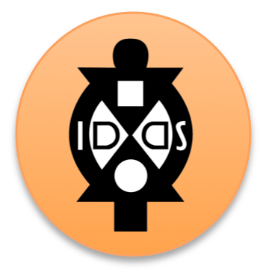
IDDS Participant Ex. Worksheet
Project Teams

Overview

There are pros and cons to forming project teams before a summit and during a summit. Where you are able, we recommend forming project teams before a summit and then re-examining them at the summit.

If you group before a summit – you have more time to consider people’s interest and their personality as you group them together. Likewise, if project teams are formed before a summit you can plan ahead the number of people for operations and design facilitators can begin doing the research necessary to prepare their team (ex. if the project topic is malaria prevention techniques, the design facilitator can do a lot of the heavy lifting research in terms of what devices already exist, who are experts in the area, government statistics on malaria, and some of the larger – but important - questions participants might not have time to research at the summit or would be great places to launch from as they are there). The downside of putting people into groups before a summit that some participants drop out within the last month and waitlisted participants from the community are added. This can take some time to reshuffle.

If you group participants at the summit – you can group people based on who is actually at the summit. As time is limited at the summit, however, you’ll want to make sure you still collect participant project preferences and personality quizzes as early as possible so you have time to review them before hand and consider groupings.

Regardless of whether you group participants before a summit or at the summit, you need to select the project topics, communities, and establish the number of people per group at least 1 month before a summit. This is so that communities can make the preparations necessary logistically, community liaisons can ensure you’re connected with the right stakeholders for the project topic, and design facilitators can begin doing some background research to make the project framing as complete as possible.
Project Teams
Project Topic | Brief Description | Community Name | Design Facilitators | #of Participants | Participant Names

Summit Name:

