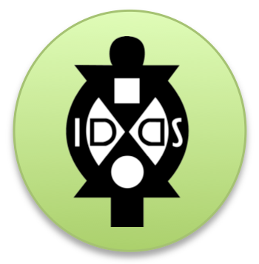
IDDS Operations Worksheet
About the Summit
Basic Info

As you know, many people want to know more about your summit. What we need is some basic info from you telling us more about your summit.

Name of Summit:

When:

Where (if you know the venue as well, please list here):

What is your eight-word mission statement:

What organizations are you working with (local or international)?

How many participants will you be looking for and what type of mix?

How many project teams?

Please tell us about your summit in 2 paragraphs or less what you plan to be doing and hope to accomplish from the summit:

Links to USAID?

- Are there any USAID missions in the area (you can check the directory here)? If so - what links, if any, do you see with the mission’s priorities and strategy?

- Is there any expected role of USAID Representative to your summit?

Blog, Logo, + Photos

As you know, your email traffic will be flooded with emails from everyone about everything. A good way to mitigate that is to start up a blog that starts sharing some of the basic info and any updates you have as they come.

What is your blog address?

Who will be in charge of creating and uploading things to the blog (this should be your communications organizer) and what is their contact info?

What will be the logo for your summit? We encourage you to be creative. The only guidance we have is that the IDDS logo must be prominent piece of it and the name of your summit should be clearly visible. Below is a copy of the IDDS logo.

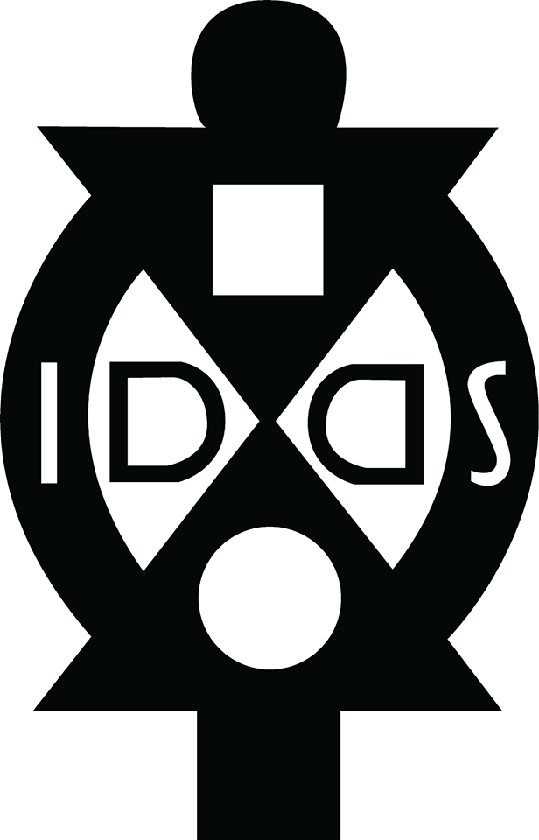

Do you have a few photos you prefer we use to help advertise your summit? If so, please include below.

