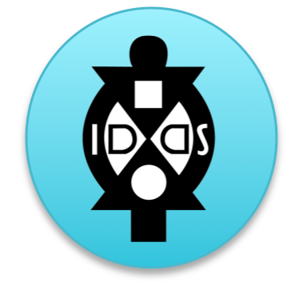
IDDS Curriculum Worksheet
Mission + Goals + Objectives
Mission

Kevin Starr, Director of the Mulago Foundation, suggests that a good mission statement is one that can be told in eight words or less. It’s long enough to be specific and short enough to force clarity. He suggests the order, “verb, target, outcome.” You can read more about the 8 word mission statements in the Stanford Social Innovation Review article.

Some examples include:
Save kids’ lives in Uganda.
Rehabilitate coral reefs in the Western Pacific.
Prevent maternal-child transmission of HIV in Africa.
Get Zambian farmers out of poverty.

Your mission statement usually embodies the ultimate hope and dream of your summit team and will be the statement we use to tell the bigger picture story of your summit to potential partners.

What is mission statement of your summit in 8 words or less?

Goals

Once you know your mission, you can set the goals for your summit. According to an article by the University of Connecticut, “Goals are broad, general statements of what the program, course, or activity intends to accomplish.” You can read more about goal formation here.

In the context of IDDS, goals tell us broadly what you want participants to learn or take-away from the experience. In a 2-week or 4-week experience, we recommend you have no more than 3-4 main goals that you choose to focus one. As you well know a good goal is specific, measurable, attainable, relevant, and time-bound. They will be good tools by which you can measure whether participants

Important note: Unlike most academic course curriculum, IDDS is a 24-7 experience where learning is happening both in and out of the lecture hall. In fact, we believe a large portion of learning happens through community visits and organized (and fun!) nighttime activities. Please keep this in mind as you plan your main goals and learning objectives for the summit.

Some examples include:
- To empower marginalized people groups with basic maker skills
- To inspire innovative thinking through co-creative design activities
- To improve livelihoods of people living in poverty by co-creating low-cost technologies
For more inspiration on writing your goals, check out Forbe Magazine’s article on 10 Things You Should Know about Goals information.

Please list in 3-4 bullet points what the main goals of your IDDS will be? What are the main things you want participants to learn?

Learning Objectives
To help choose which activities you want to do at an IDDS, it’s helpful to know what your specific learning objectives are. Though there are many things we would love to teach participants, we all know that there is only so much time at an IDDS.

Some sample learning objectives include:

For each goal that you have, please share with us what are your top 2-3 learning objectives.

Goal 1:

First Learning Objective for Goal 1:

Second Learning Objective for Goal !:

Goal 2:

First Learning Objective for Goal 2:

Second Learning Objective for Goal 2:

Goal 3:

First Learning Objective for Goal 3:

Second Learning Objective for Goal 3:

