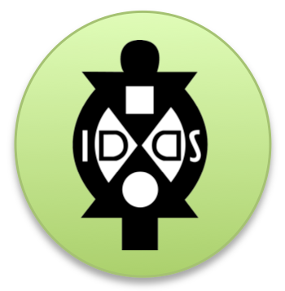
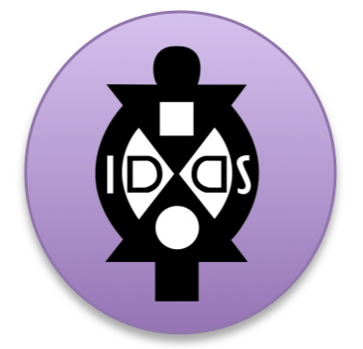
IDDS Communities Worksheet
Culture + Context + Visas

Map it out!

Most people will want to know where your summit is being hosted. Please share with us a map of the country the summit will be hosted in. Please mark where the summit will be, where the airports are that you recommend people fly into, where the communities are (if you know) that you’ll be working with, and any other relevant info.

Languages + Translation

What languages are spoken in the area where the summit will be held?

What languages are spoken in the communities that you will visit?

What type of translation are needed for and will be available at the summit?

A bit about the culture!
When people consider in participating in the summit, it would be helpful for them to know a bit about the culture. Below are a few areas of information you could share with interested applicants. We recognize there are books written on these topics so no need to write a dissertation on the items (you’ll have an opportunity to share more about them later with participants), just give them a few sentence overview to understand the context and feel free to link to external sources such as CIA Factbook, CDC, etc.

It’s helpful to have information posted that informs people about:

- Geography + Language + Currency
- Political Structure
- Family Structure
- Gender + Sexuality
- Religion + Spirituality
- Time + Relationships Perceptions

Additionally, it would be exciting for perspective participants to know about:

- Types of food
- Types of music + dancing (feel free to post any YouTube videos you know of)
- Other books, videos, or websites relevant to the history, culture, or context

Visas

Are there visas that international participants need to obtain to enter the country? If so, what is the process and how long does it take?

What is the website people should refer to for more questions about the visa process?

