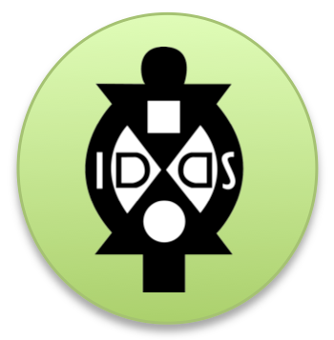
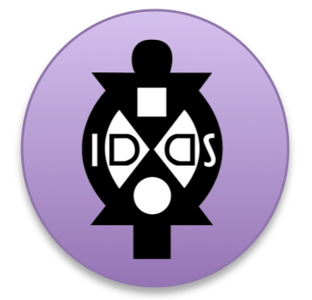
IDDS Communities Worksheet
Understanding the Culture

Posting on the Blog Before the Summit

Culture is a big topic. There are dissertations written on specific pieces and larger pieces of this. However, what we need to do is give our participants and guests just an overview of the key pieces they need to know. If you have references of other books, sites, etc. they should refer to, feel free to include.

At this point, it would be helpful to have a blog post that addresses each of the following points with just a few sentences each.

- Geography + languages + currency
- Time + Relationships
- Political Structure
- Family structure
- Gender + Sexuality
- Religion + Spirituality
- Diversity + Foreigner Perception

If there is time, it is may be helpful to address the following as well. Otherwise you can address these at the summit during cultural orientation:

- Workplace Etiquette
- Eating Customs
- Bathing Customs
- Gift Giving
- Celebrations + Grieving

Please share your blog post link here and/or copy the information you wrote:

Culture + Safety
Many people (participants, organizers, and special guests) will have questions about health and safety issues regarding the summit.

If you have not made a post yet on the blog, it would also be helpful make a post that informs people of:

- The current health and safety issues relevant to the area. For health advisories, we recommend you reference the CDC site for the country you will be hosting in. For safety advisories we recommend cross-listing what embassy safety websites list, in addition to any others you kno.

- Your IDDS’s plan for Health + Safety. Here is the IDDS Health + Safety Protocol that you can adapt for your summit. Be sure to clarify that people will be traveling in groups, you have a schedule, you will be covering cultural information to inform participants and organizers of safety tips relevant for the local context, and people will be traveling with locals.

- Appropriate materials of what to pack. This would include a list of appropriate clothing (both for the country’s culture and for the workshop context), medications, appropriate gifts, etc.

Please share your blog post link here and/or copy the information you wrote:

